**Submit a (minimum four page) site. All of the pages must use a common header, footer, and navigation across all pages. Each page must have a unique title**

All pages use common header, footer, and navigation with four pages in total. There is skip to content on every page and it’s set to the first tab order

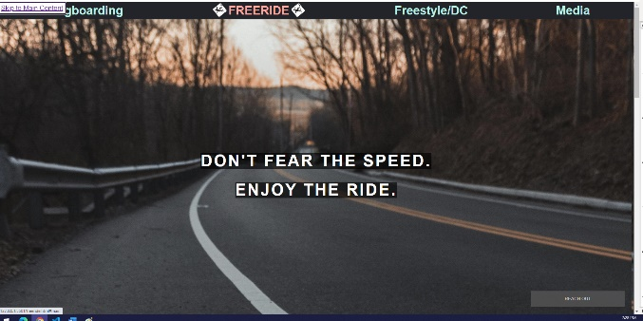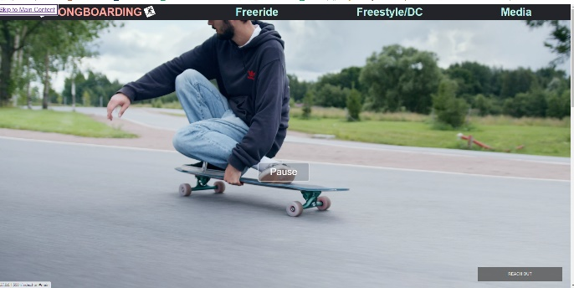



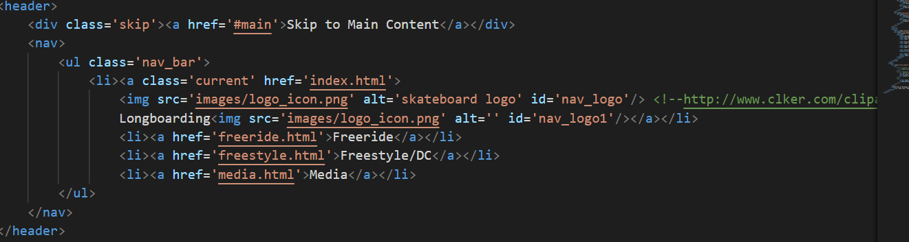

**The navigation must clearly display the current page within the nav element.**

**As you visit each page, point out how the navigation bar changes to clearly indicate which page you are currently viewing.**

The navigation displays the current page clearly with uppercase and logo around current page.



**Each page should contain a main section that can be reached using a Jump to Content option with the first tab on the page. Main must be after the navigation.**

**To demo this, select "Skip to Content" and then hit tab again. Show us where the focus is now.**

Skip to content works as shown in the first criteria

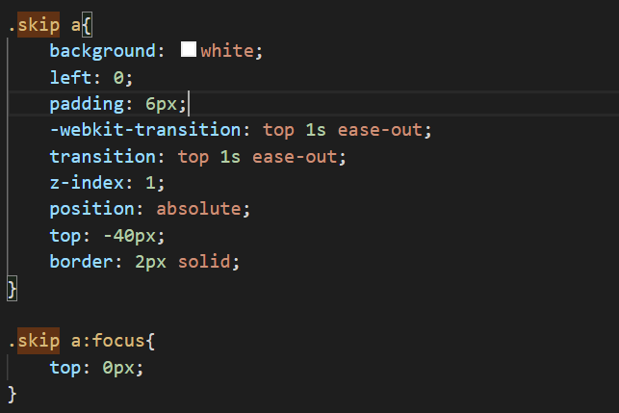

**Minimum content present. This includes a page that has at least nine (9) images.**

Minimum content present, each page has a few paragraphs combined with images and videos. On the freestyle/dc page. more content will display when the different options are clicked

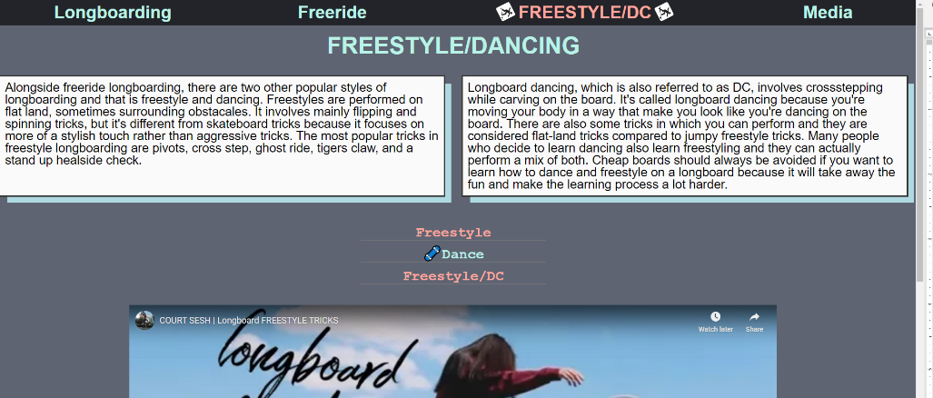

**Grid - used more than once, and used effectively.**

Grid was used on all four pages. (Comparison with&without)

1. index page where the main content is (class = index_content). Everything is out of place without grid. I used grid to change layout on all four views, mobile, tablet, desktop, super large screens

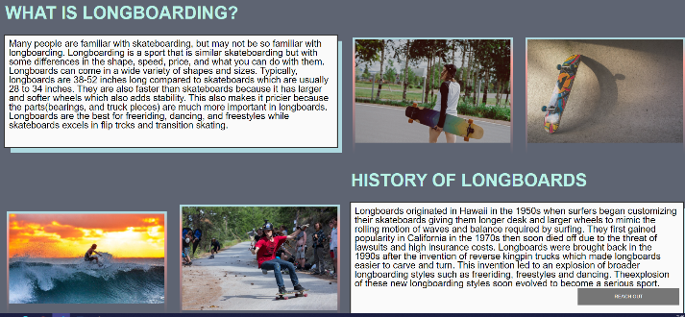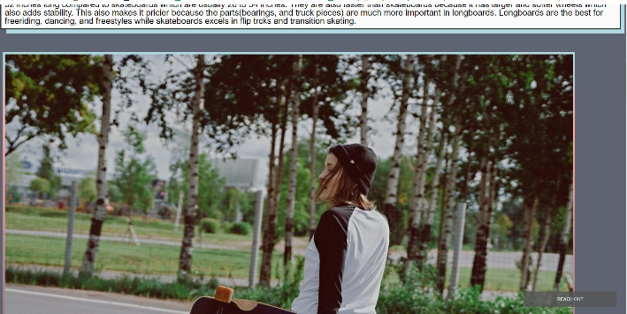

1. video gallery on my freestyle page (class = video_gallery) Used to sort my label and videos in the order and place I wanted. I used grid for mobile and desktop view here.

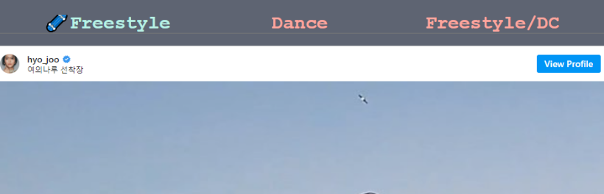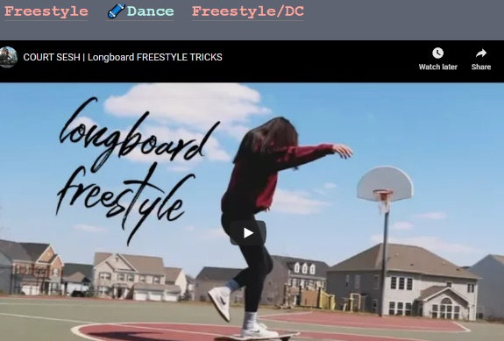

1. image gallery on my media page (class = image_gallery) used to order the images and place them where I wanted. Mobile, tablet, and desktop view all cha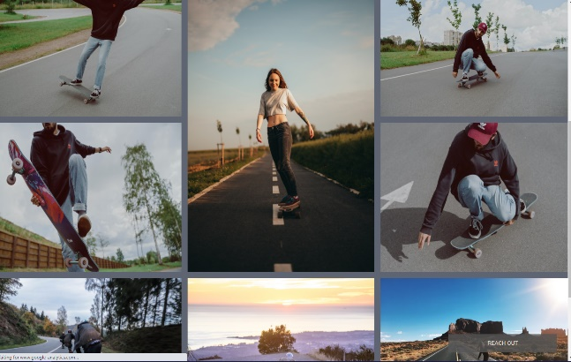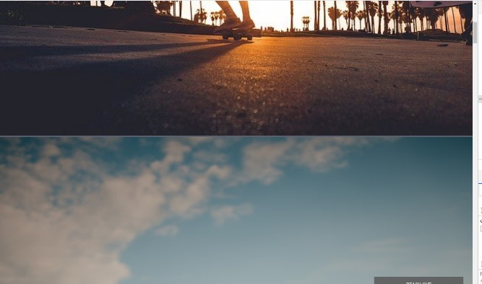
2. image container on freeride page (class = img_container) Only used on desktop view

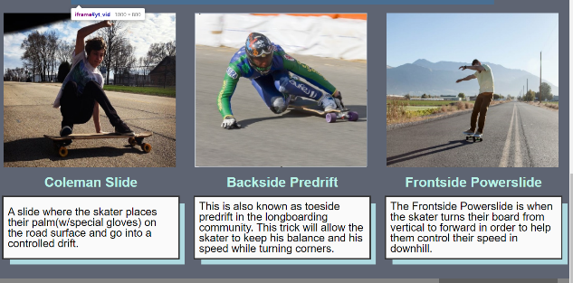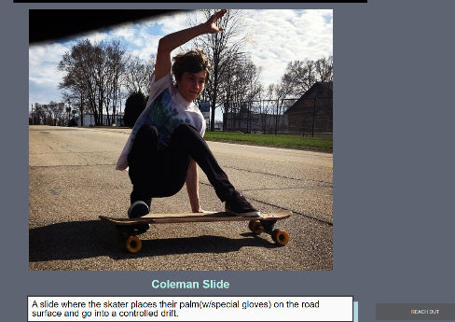

**Flex - used more than once, and used effectively.**

Flex was used on navbar, footer, video button, flip card, parallax, and freeride page’s content

1. Flex used to change nav bar on mobile and tablet view (class = nav_bar)

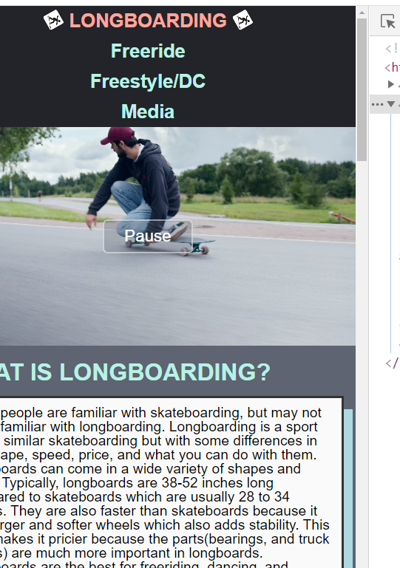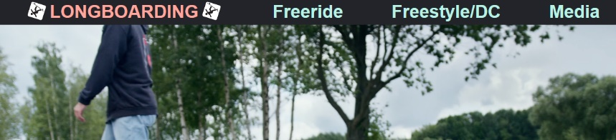

1. Flex used to display social media buttons differently according to the viewport. It changes on mobile and tablet (class = social_media)



1. flex used on my pause button on index page (class = overlay). This was used to get the button to show on top of the video and centered. Pause button does not show without it

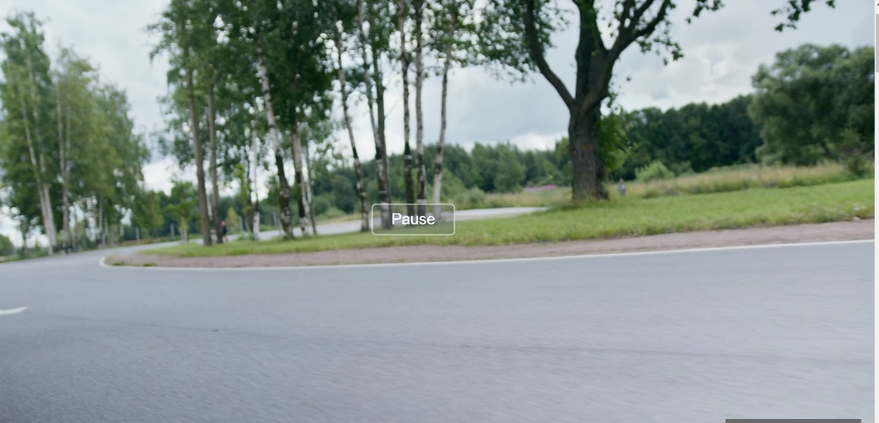

1. flex used on flip card on index page. (class = flex_card_section, flex_card_flexbox). This changes the layout of my flipcard based on all viewports.
2. parallax content (class = parallax). Same use as the pause button, so that it overlays the background image where I want it to.
3. freeride page’s contents also uses flex (class = freeride_content,& p,& h2,& h3)
4. used to align everything in the center of page, wrap border around text and align text.

**At least one CSS generated animation that is NOT part of the gallery.**

My css animation is in my navigation bar. I animated the logo to spin forever. animation-timing-function smoothens the spinning action.

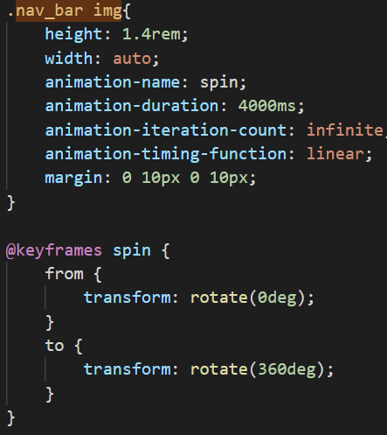

**A working contact forms. Show us the email you receive after clicking on the form.**

My form will require name, email, phone and message to all be filled. With phone number in specific format. It automatically validates the email address before sent

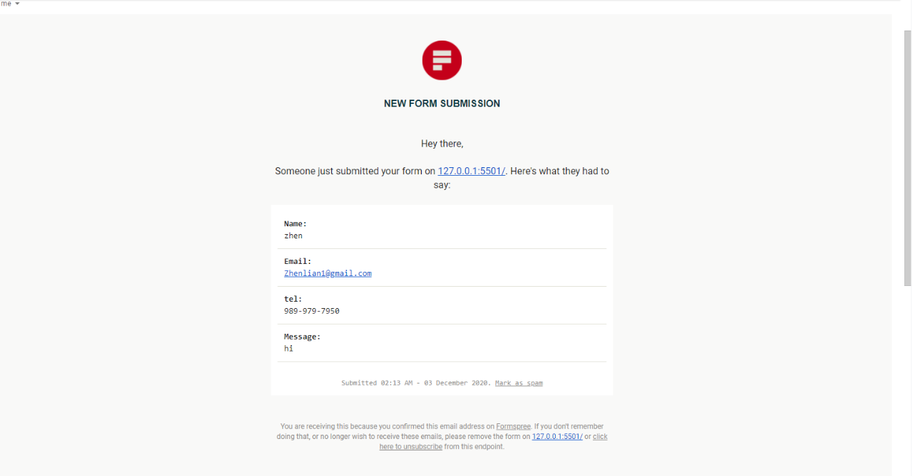

**A parallax image**

Parallax image is on freeride page. (class = ‘parallax)

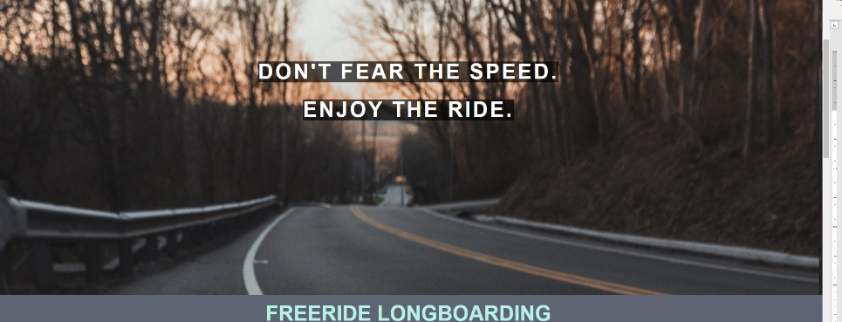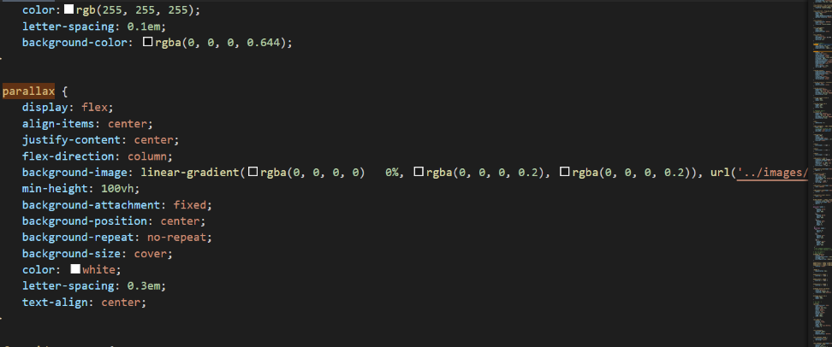

**A keyboard accessible flip card using just CSS**

Flip card using only css, it works with mouse hovering and by tabbing (class = flip_card)

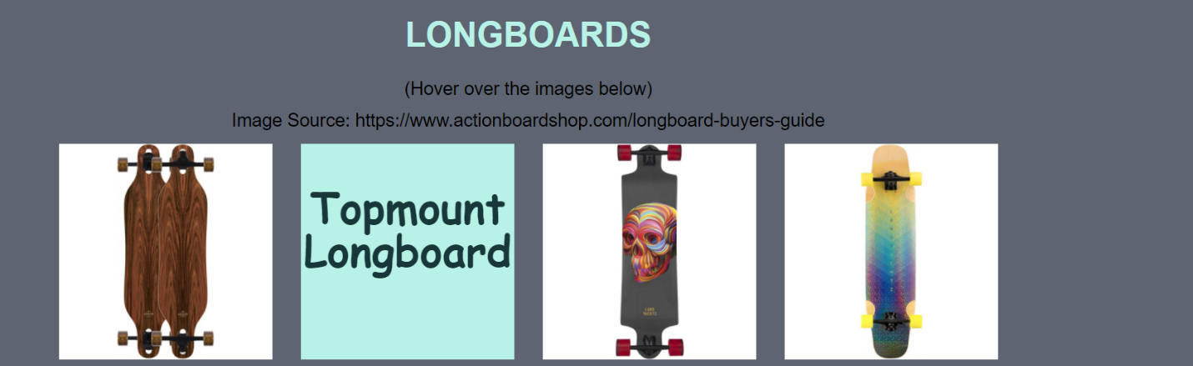

**Google Analytics on all four pages.**

all properties/views on Google Analytics works, this includes Acquisition, Engagement, Monetization, Retention, Demographics, etc.. Everything on the left menu

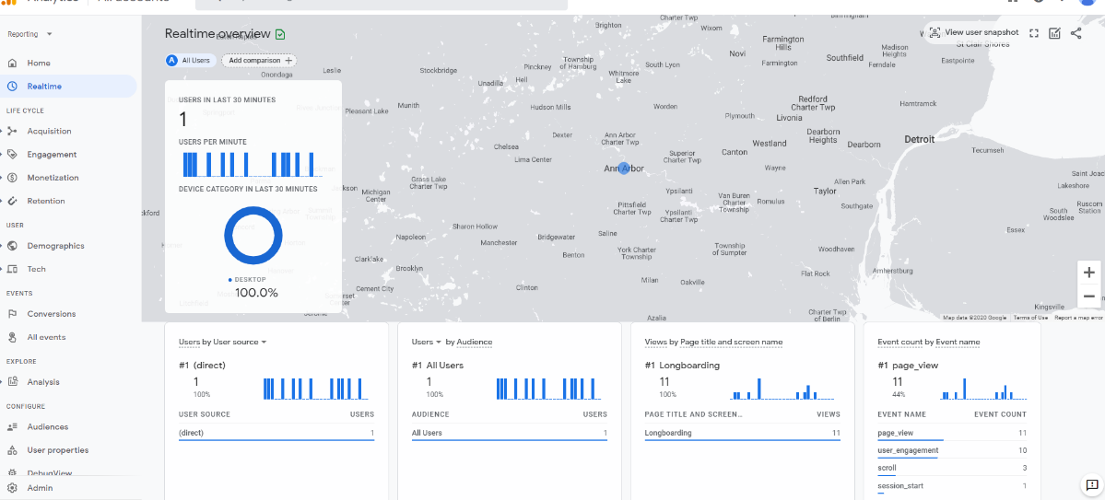

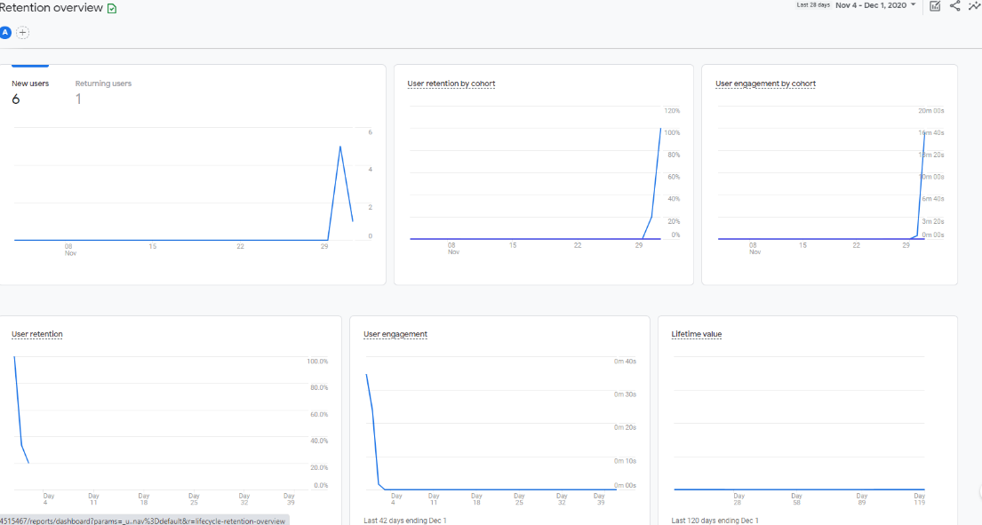

**Visually appealing**

**What did you do to make your page particularly appealing? Tell us more about your font choices, image editing, etc. I am sure are things that you did that we can't easily see.**

I went to <https://coolors.co/> to find a color pallet that I liked then I picked those colors and changed all the colors on my site. I chose fonts that were accessible so Arial and sans-serif primarily. I had some fonts like Comic Sans MS which were not as accessible, but I only used them for things like flip card. I edited the images and videos so that they were the size that I wanted based on vh and vw. I realized that percentage-based units were better for responsive design very late into the project which would’ve made it a lot easier to resize things.

**Media Query One & Media Query Two**

**Using the browser of your choice, walk us through the different responsive design choices you made. Make sure to impress us. The changes should be drastic, obvious, and should improve the look/functionality of the site.**

I kind of explained this throughout the documentation and how I used it. I have four viewports, mobile, tablet, desktop, super large screens. I changed my headers and paragraphs, some margins, video and image resizing on pretty much all the viewports. As well as flex and grid stuff. My super large screen(min-width: 1600) was created mainly for my index page. I really didn’t like how it looked when viewport was greater than 1600px so I created it.

**Reduced Motion Media Query**

I have reduced motion for every animation I made in my website.

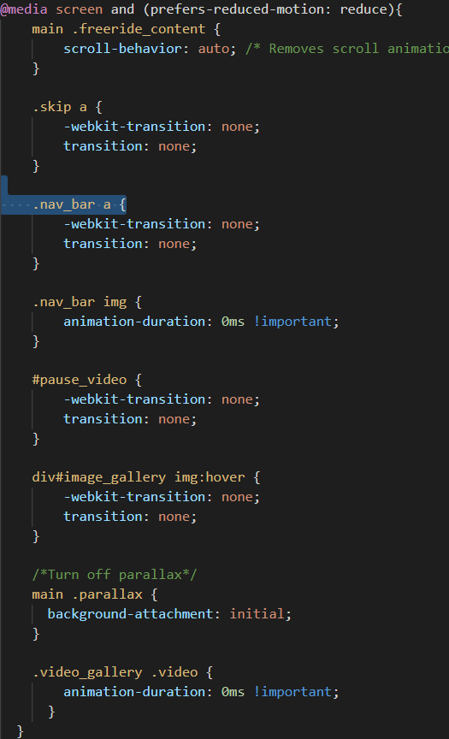

**Documentation/Demonstration - Responsive Design**

I have great responsive design because I built my site mobile first, responsive based on viewport with fluid design.

**Documentation/Demonstration – Validation**

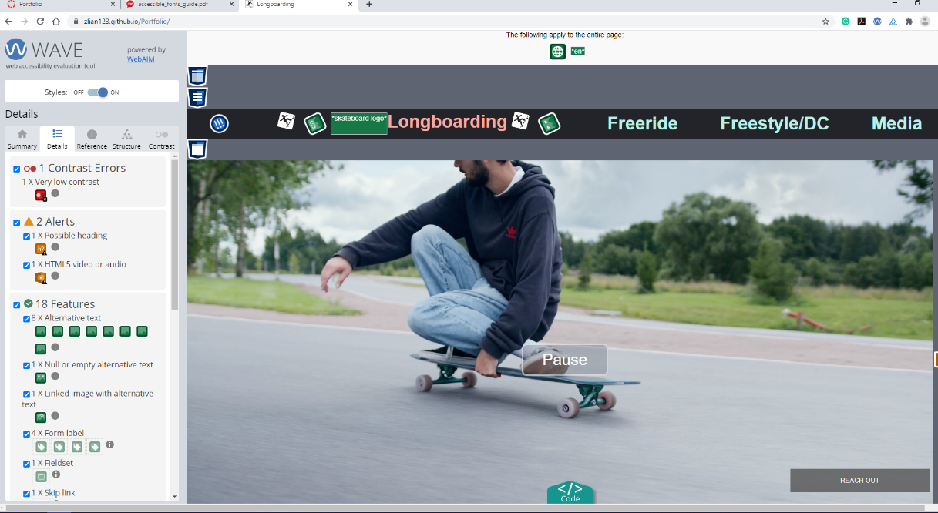

I have one contrast error on index page. This error is not an issue because it is caused by the embedded video that I have. The color that is in conflict is #000000 and my background color which doesn’t exist on my site because I never used a black color.

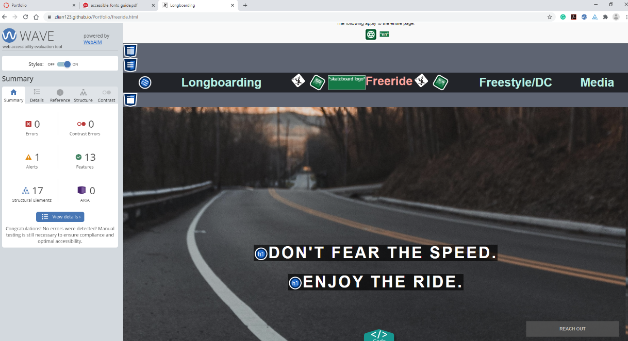

The Freeride page has no contrast errors. It shows one contrast error sometimes when you validate the site too quickly while the page is still loading.

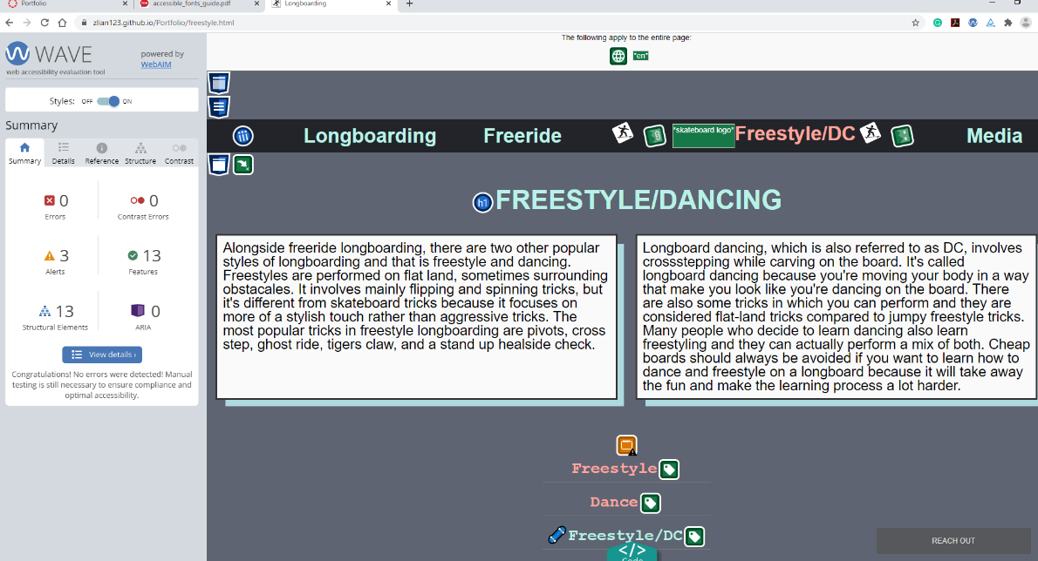

The 3rd page has no errors on wave. Again, if waved too early I get a weird contrast error, but it’s not a problem because I believe that’s just from the page loading so everything is gray

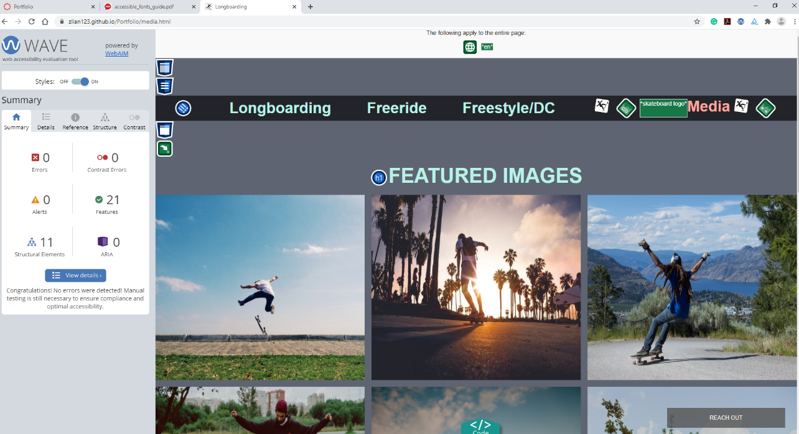

The last page has no wave errors.

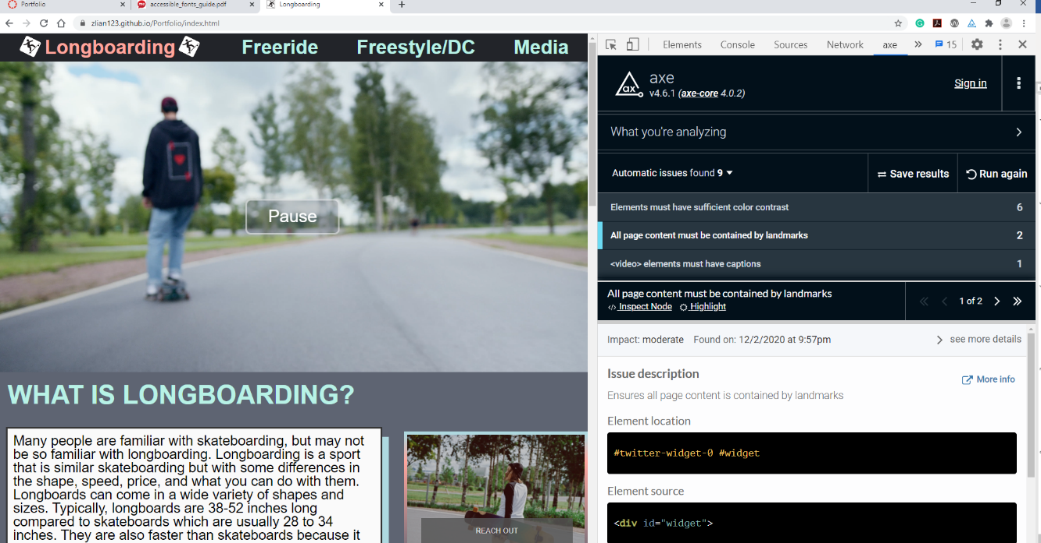

1. All page content must be contained by landmarks[2]. This is caused by my twitter widget in my footer. I believe that it’s not recognizing that my twitter button is within my footer tag, maybe due to the twitter code. This is not an issue because it does not affect anything on my site.
2. Video elements must have captions. This is not an issue because my video is automated and its just a video playing, no sound or music.

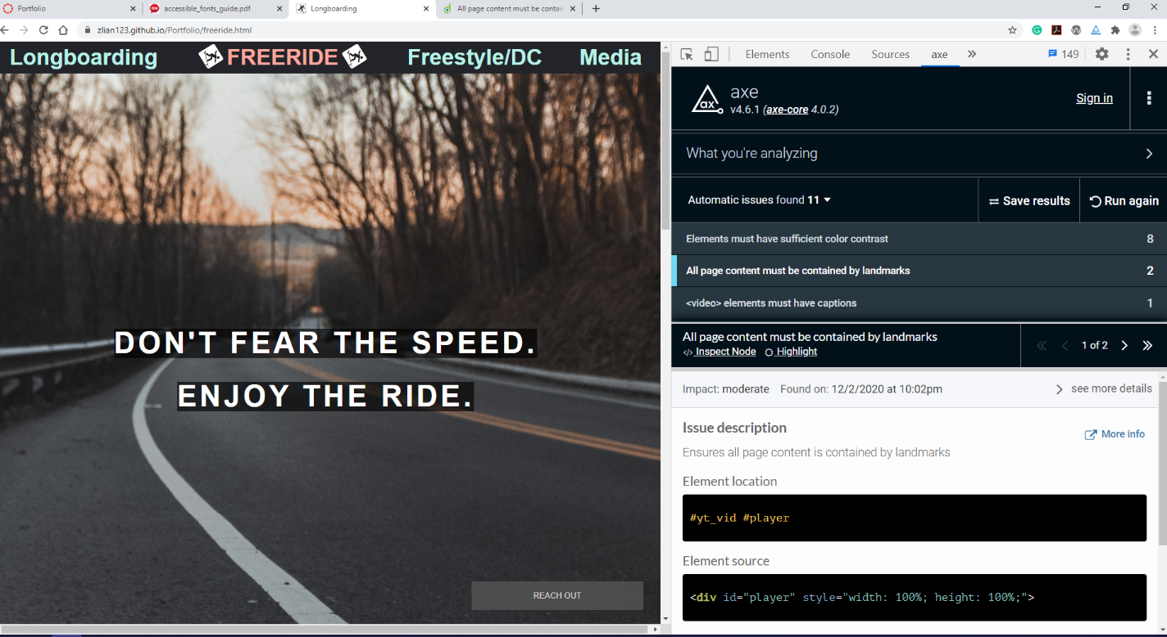

1. All page must be contained by landmarks[2, sometimes 3]. This is again my twitter widget and my embedded YouTube video. For the same reason, it does not affect my site’s usability or accessibility so it is not an issue.
2. Video elements must have captions. The youtube video has no one talking, it has a background music. Caption is not an issue.

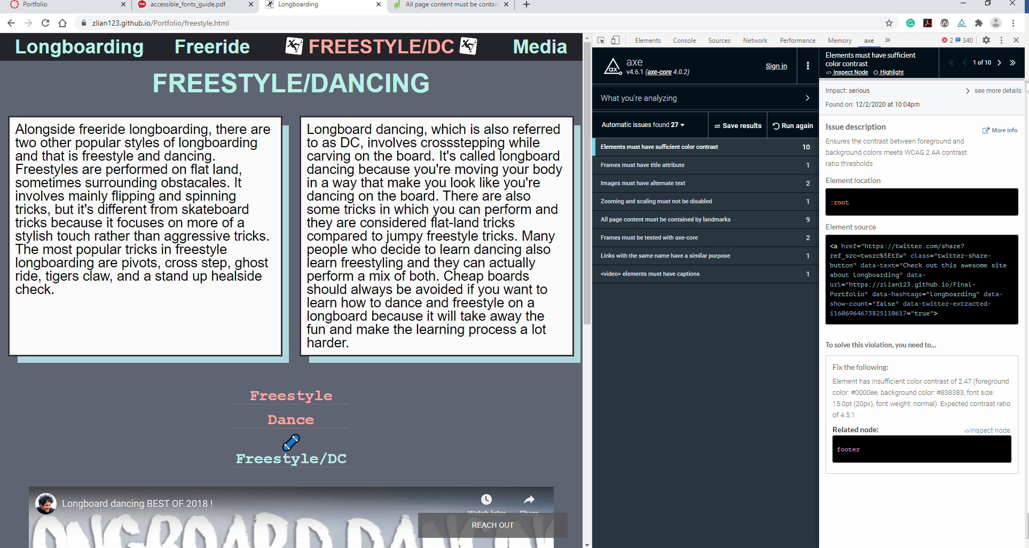

1. video must have caption error. not an issue because not one is talking.
2. I get an error with facebook share button this time. This is not an issue because it doesn’t affect my site’s usability and accessibility or in any way. I have the same facebook code for every page but only this one gets an error. I think it’s just facebook’s button doing some crazy stuff so it’s not an issue.
3. the rest are Instagram’s embedded video errors. They are not an issue for the same reason, they don’t affect my site in anyway. The Instagram copyright’s documentation also states that anyone using Instagram’s embedded video code may not edit or modify the code in any way.

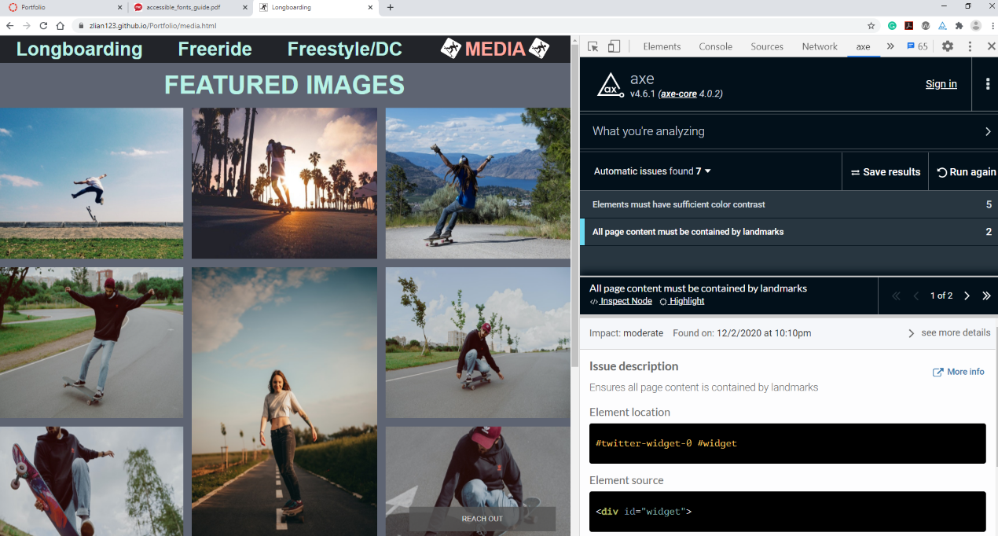

1. This is the same twitter widget error. Which is not a problem for my site.

**Documentation/Demonstration - Accessibility, diversity and inclusion**

Accessibility: image alt text, meaningful headings and not for font size, passing color contrast, accessible font-size and font-family, form provides clear instructions and keyboard access, labels, media query reduced to turn off animations.

Diversity & Inclusion: images and videos representing both women and men. I mentioned not just the longboard community but also skateboard, and penny board community. Accessibility for people with disabilities(ex. I went back and changed most of my div tags that should’ve been more meaningful, I used sections and article tags instead). My content is easy to understand so it’s easy read for people with any education.

**EXTRAS**

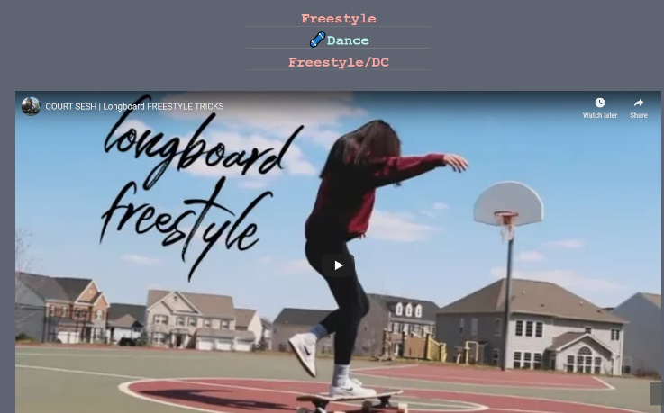

Something extra I did was my video gallery. I got the idea from googling website ideas for image gallery. I used mainly animation, and keyframes to implement this. When the page is loaded, whatever is not selected has opacity of 0 which makes it transparent, but this doesn’t hide it and it would still take up space. So, I used keyframes and made it fade away. At 100% its opacity is 0 and I set the width&height to 0 so it would essentially ‘hide it’. When I click on a different label, the current video fades away and the new video fades in by setting opacity to one, and height&width to 100%.

Another extra animation I did was in my image gallery located on the Media page. On hover, my images zoom in with over flow hidden. I think I saw this on Canvas or Piazza’s login page and I made it work with my image gallery.

I couldn’t make my site fully accessible by only using the keyboard sadly because I couldn’t figure out how to tab out of the Instagram controls. But my other pages are keyboard accessible with tabbing. I went into my code and changed some tags to make it more meaningful such as sections and article tags instead of div. There was some code which I couldn’t add an article tag which I think would’ve helped make my code more semantic to screen readers because I went in too late and adding tags messed up my grid and flexbox.